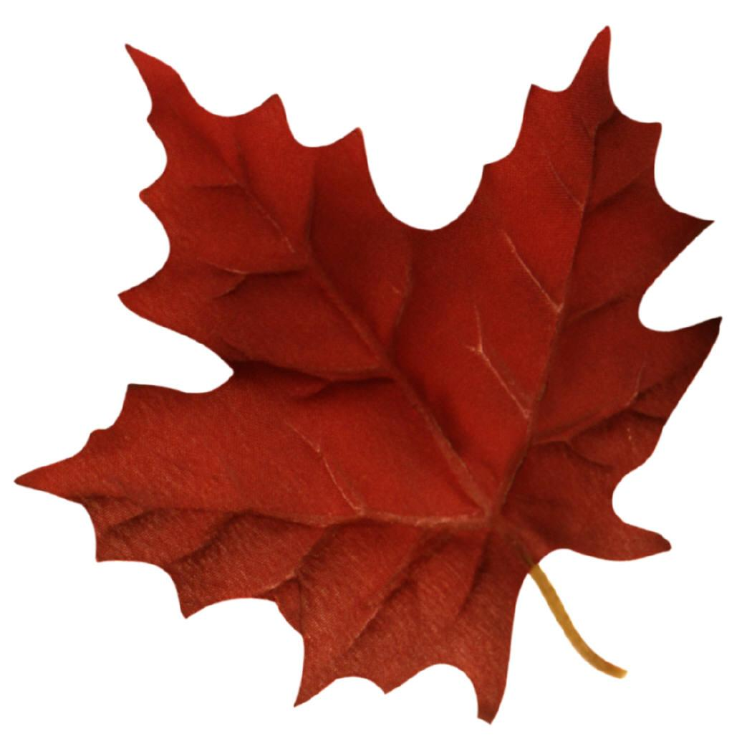
Name Due Date

Monitor My Maple Lab

Part I: Data Collection: Collect data and answer the questions below about two different maple trees.
Tree # | Latitude |  | Longitude
 | Inches | Centimeters (cm) | Meters (m) | Kilometers (km)
Circumference
Height

- Is the tree located within 100 feet of building, concrete, or asphalt? Yes/No

- What kind of habitat is your site?
Home lawn Home garden School Lawn Other
School garden School paved area City/Community Park
Natural Setting (non-developed park, refuge, open space, forest)
- Describe the shading at the site
- Open (more than 5 hr per day of direct sun)
- Partially Shaded (2-5hr per day of direct sun)
- Shaded (less than 2hr per day of direct sun)

- Does the tree look healthy?

- Changing Color
- Early: Only a few leaves have turned color (less than 10%)
- Middle: Many leaves have turned color
- Late: Most or all leaves have turned color (more than 90%)

- Leaves Dropping
- Early: Only a few leaves have dropped (less than 10%)
- Middle: Many leaves have dropped
- Late: Most or all leaves have fallen (over 90%)

Tree # | Latitude |  | Longitude
 | Inches | Centimeters (cm) | Meters (m) | Kilometers (km)
Circumference
Height

- Is the tree located within 100 feet of building, concrete, or asphalt? Yes/No

- What kind of habitat is your site?
Home lawn Home garden School Lawn Other
School garden School paved area City/Community Park
Natural Setting (non-developed park, refuge, open space, forest)
- Describe the shading at the site
- Open (more than 5 hr per day of direct sun)
- Partially Shaded (2-5hr per day of direct sun)
- Shaded (less than 2hr per day of direct sun)

- Does the tree look healthy?

- Changing Color
- Early: Only a few leaves have turned color (less than 10%)
- Middle: Many leaves have turned color
- Late: Most or all leaves have turned color (more than 90%)

- Leaves Dropping
- Early: Only a few leaves have dropped (less than 10%)
- Middle: Many leaves have dropped
- Late: Most or all leaves have fallen (over 90%)

Part II Leaf Identification, Measurements and Conversions
- Using the diagram below determine the height and width of each leaf sample in cm. Record measurements in the table below. Convert into meters and centimeters.

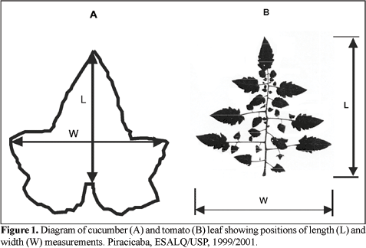

- Using the scales on the lab table determine the mass of each leaf sample in grams rounding to the nearest hundredths place. Record in data table and convert into kilograms.
Sample Number | #1 | #2 | #3 | #4 | #5
Leaf Height (cm)
Leaf Height (m)
Leaf Height (km)
Leaf Width (cm)
Leaf Width
(m)
Leaf Width (km)
Mass (g)
Mass (kg)

- Using leafsnap.com try to identify your five leaf species. Complete the table below.
Sample Number | #1 | #2 | #3 | #4 | #5
Genus species
Native Habitat Location
Native Habitat Description
Species Description (height, fruit, nuts, life span, etc.)
How is this tree a resource?

- Clean up! You will need to tape your leaves to a piece of wax paper with your name(s) on the paper. Place the tape on the stem so you do not damage the leaf.
Part III Graphing: Using graph paper, create the following graphs. Be sure to label the axis and create a title for each graph.
- Create a graph comparing the height of your leaf samples.
- Create a graph comparing the width of your leaf samples.
- Create a graph comparing the mass of your leaf sample.

