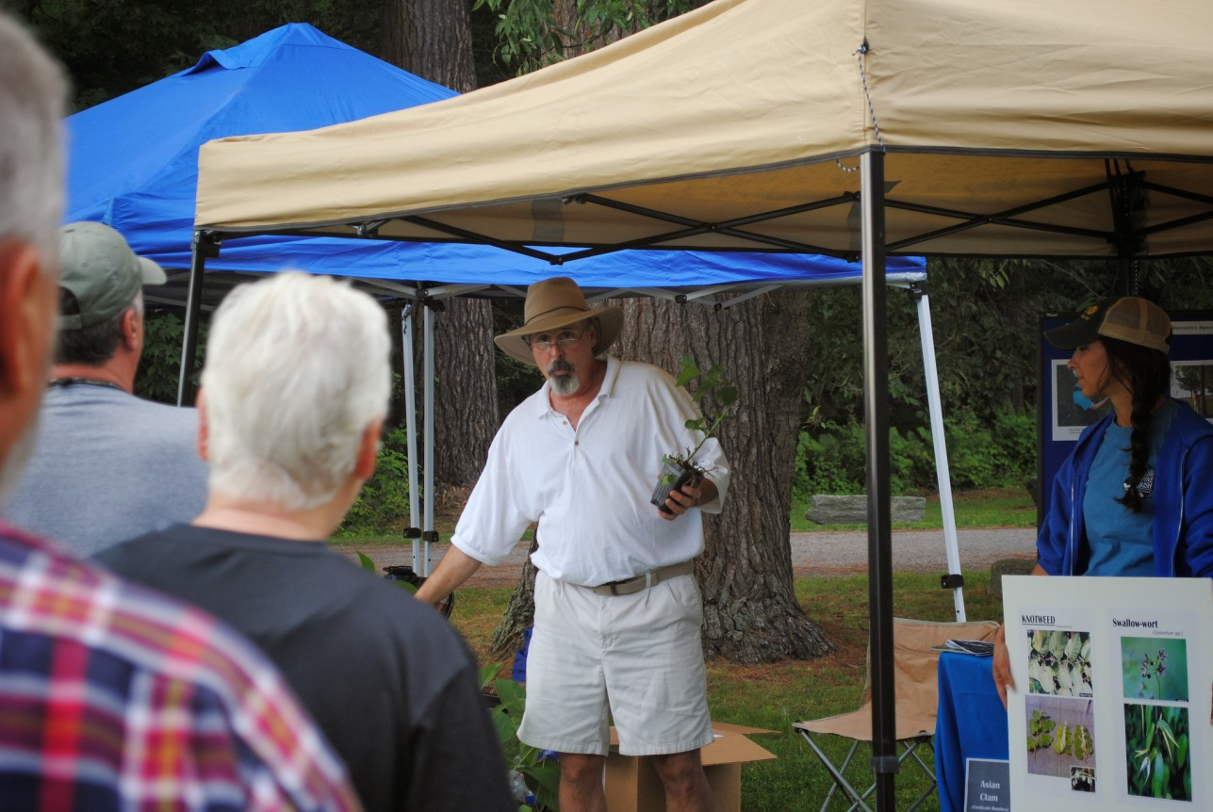 

**Surveying**

**for Invasive Species**

*Please join us to*

**Learn the skills to survey your favorite waterbody or landscape for invasive species***.*

**Part 1** – This 35 minute session will teach you how to identify five common invasive species along with the skills to survey your favorite water body or landscape. Session begins promptly at 8:30 AM to 9:05 AM

**Part 2** – During this “optional” 2 hour volunteer activity we will canoe and/or kayak the Salmon River Estuary (west end) to survey for the invasive plant Water Chestnut. Participants will “hand-pull” the plants and return them to shore. Participants will be engaging in an actual surveying event.9:15 AM to Noon.

**When:** Saturday July 11th 2015, beginning at 8:30 AM.

**Where**: Pine Grove State Boat Launch - 7101 State Route 3, Pulaski, New York.

**What To Bring:** Eagerness to learn, proper attire, camera. If you plan to participate in community hand pull. Please bring your own canoe or kayak & safety equipment.

**Weather Note:** This is an outdoor event and will take place in light rain.

**Please R.S.V.P**. at 315.387.3600 x 24 so that we can contact you in the event of severe weather

For additional information contact:

John DeHollander, Oswego County SWCD @ 315.592.9663; Megan Pistolese SLELO PRISM Educator @ 315-387-3600 x 7724

Sponsored by:

Oswego County Soil & Water Conservation District &

St. Lawrence Eastern Lake Ontario Partnership for Regional Invasive species Management

**Sponsored in part by**

**St. Lawrence**

**Eastern Lake Ontario**

**Partnership for Regional Invasive Species Management**

Please join us in celeb 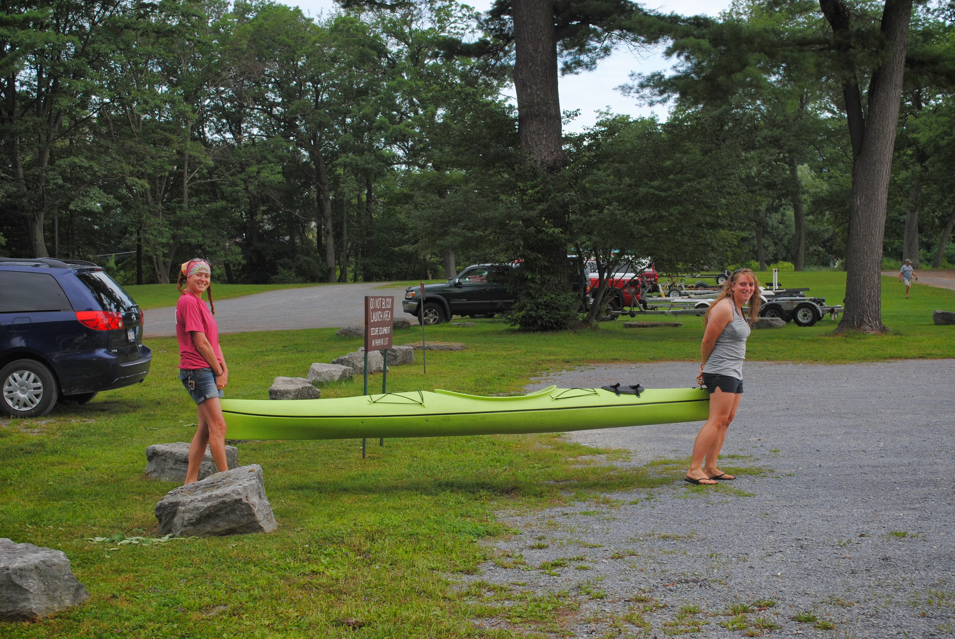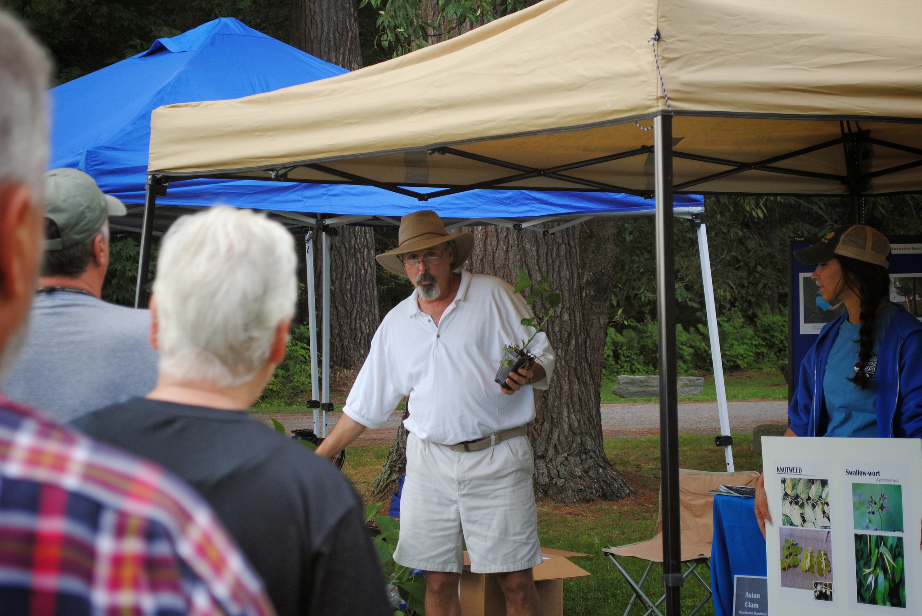rating Oliver’s sixth birthday with cake, candles, and ma https://c2.staticflickr.com/6/5494/9949745826_3a01c43d45_k.jpgny happy wishes. Bring the whole family!