Monitor My
Maple Project
Guide for K-12 Educators

Monitor My Maple is a Nature Up North Citizen Science project that engages North Country residents in observing phenology, or seasonal changes, in local maple trees. Recent research indicates that maple growth is declining in our region, and there is concern among scientists about how a warming and increasingly unpredictable climate will affect both maple health and maple syrup production. Through our Monitor My Maple unit curriculum and laboratory activities, students collect citizen science data to contribute to our knowledge of how climate, habitat, and human activities are affecting these cherished local species-and meet NYS Next Generation Science and Literacy standards at the same time. Explore this laboratory guide and our online resources (www.natureupnorth.org/monitor-my-maple-project) to see if MMM is right for you and your students.
The Monitor My Maple laboratory activity is designed as a resource that may be used at any point within your unique curriculum.
Note: Nature Up North asks that you collect data at least twice throughout the semester and that your report all data, including interpretations of Monitor My Maple data, to natureupnorth.org in order to ensure reliable and wholistic data. Data collection is best completed between August and the third week of October for the fall project and between March and late April for the spring project. A Nature Up North Team member would love to visit your class to introduce Monitor My Maple to your students and offer support during your first observation! Thank you for your interest in Nature Up North and place-based environmental education. And thank you for helping us to monitor our maples!
Materials:
- A tape measure or cloth measuring tape to measure the circumference of your tree
- A string (if you are using a metal tape measure)
- A paper data sheet or smartphone
- Internet connect (to log observations on natureupnorth.org)
- Tree numbering tags (optional; ask Nature Up North Project Manager for details)

Next Gen Standards:
HS-LS1-5 Use a model to illustrate how photosynthesis transforms light energy into stored chemical energy.
- Emphasis is on illustrating inputs and outputs of matter and the transfer and transformation of energy in photosynthesis by plants and other photosynthesizing organisms.
HS-LS2-2 Use mathematical representations to support and revise explanations based on evidence about factors affecting biodiversity and populations in ecosystems on different scales.
- Mathematical representations include finding the average, determining trends, and using graphical comparisons of multiple sets of data.
HS-LS-7 Design, evaluate, and refine a solution for reducing the impacts of human activities on the environment and biodiversity.
HS-LS4-6 Create or revise a simulation to test a solution to mitigate adverse impacts of human activity on biodiversity.
- Emphasis is on testing solutions for a proposed problem related to threatened or endangered species, or to genetic variation of organisms for multiple species.
HS-LS4-5 Evaluate the evidence supporting claims that changes in the environmental conditions may result in: (1) increases in the number of individuals of some species, (2) the emergence of new species over time, (3) the extinction of other species.
- Emphasis is on determining cause and effect relationships for how changes in the environment such as deforestation, fishing, application of fertilizers, drought, food, and the rate of change of the environment affect distribution or disappearance of traits in species.

Objectives:
- demonstrate how to find the circumference of a maple tree
- record damages/diseases of maple trees
- observe and record phenology, seasonal changes, in local maple trees
- state the importance and benefits of citizen science

Curriculum Outline:
The following are possible curriculum outlines for Fall and Spring Monitor My Maple. The order of the units may vary in order to fit your unique curriculum design and the use of these outlines are completely optional. You may prefer to do observation 2-4+ informally and as extra credit or homework assignments.

Monitor My Maple (MMM) Curriculum Outline – Autumn
Tips: Collect MMM observations a frequently as possible – ideally once or twice a week until the third week of October. Collect 2-4+ observations.
Observation Number | Unit Topic | Connection
1 | The Scientific Method and the Metric System | Introduce MMM and ask students to determine the scientific question and purpose. Students may then form hypotheses about the growth of their trees and related factors. For example, the amount of shading vs. tree growth. Students can use the circumference of their trees and measurements of their leaves to practice metric conversions.
2 | Biology Introduction | During this unit, you may wish to discuss what biologists do. Nature Up North has resources on natureupnorth.org that include interviews with local biologists. A member of the NUN team would love to visit your class and discuss their role as scientists. It may be a good time to talk about Citizen Scientists and the students’ roles in monitoring our maples.
3 | Microscopes and Cell Biology | During this unit, students may look at the leaves of their maples under the microscope to practice using the microscopes. This can then be an introduction to cell biology and the structure of plant cells. This activity would likely occur before the state mandated lab, “Diffusion Through a Membrane.”
4 | Photosynthesis | By this time, the leaves will likely have changed colors. Students can consider the scientific explanation for this phenomenon and how it relates to photosynthesis. Are the maple trees still performing cell respiration?

Note: We suggest that additional observations be assigned as homework or extra credit outside of scheduled observation days in order to maximize the number of observations and achieve the two-observation minimum requirement.

Monitor My Maple (MMM) Curriculum Outline – Spring
Tips: Collect MMM observations a frequently as possible – ideally once or twice a week until the third week of October. Collect 2-4+ observations.
Observation Number | Unit Topic | Connection
1 | Genetic Engineering | The purpose of Monitor My Maples is to monitor the health and growth of local maple trees in order to keep track of any possible population decline. One of the newest conversations in science is the possibility of genetically modified trees. Genetically modified genes could enhance biomass and maintain biodiversity by selecting for favorable traits in trees, such as wood properties, stress resistance, etc. Monitor My Maple could be introduced during this unit and students could begin considering the implications of genetic engineering for the maple tree population in the North Country, including its pros and cons. Sugar industry
2 | Evolution | In an introduction to evolution, students could consider the traits of maple trees and the advantages these traits offer in their environment. This could lead to a discussion of the loss of traits and species over time due to changes in the environment (in the case of maple trees, climate change). Specifically connecting to standard HS-LS4-5 Evaluate the evidence supporting claims that changes in the environmental conditions may result in: (1) increases in the number of individuals of some species, (2) the emergence of new species over time, (3) the extinction of other species.
3 | Ecology | Monitor My Maple can provide real examples of carbon cycling, food chains, food webs, and the movement of matter and energy through an ecosystem. Students may consider the decline of maple trees and the effects that this may have on the environment in the North Country.
4 | Human Impact | Human activity and climate change affect the population of our maples in the North Country. One of the conversations that usually gets omitted is the affect that climate change and population declines of other species have on humans. Monitor My Maple could provide an opportunity to discuss the effects of human behavior on maple tree populations as well as how this population decline affects humans in the North Country. For example, livelihood through maple sugaring.

Note: We suggest that additional observations be assigned as homework or extra credit outside of scheduled observation days in order to maximize the number of observations and achieve the two-observation minimum requirement.

Monitor My Maple Procedure
Before going into the field:
- Create a user account. In order for student to enter maple data on natureupnorth.org, they must be logged in with a verified user account. There are two ways to do this: either create a user account that the entire class will share or have students create their own accounts. To create a user account on natureupnorth.org, click “Sign Up/Log In” in the upper right corner of the home page.
Note: According to the Children’s Online Privacy Protection Rule (COPPA), students under the age of 13 are not permitted to create online user accounts. Teachers with students Teachers with students under 13 will have to create a class account with a single shared password. We recommend this “class account” approach to all classes, as students often forget their passwords and not all students have personal email accounts.
- Print out/hand out Monitor My Maple Lab and data sheets. PDF versions are available from the Educator Resource page under Monitor My Maple. If students have smartphones or tablets with data plans, they may enter data directly into the online platform.
- Assign groups. Typically, students work in teams of two or three to monitor a single tree.

1. Tree Identification and Tagging
Tree Identification: Identify and select trees to monitor. You may select the trees the students will monitor or allow the students to choose their own.
There are five species of maple native to St. Lawrence County – sugar, silver, red, striped, and boxelder. Several other species have been introduced, including Norway and Japanese maples. For this project, we are particularly interested in sugar maples. However, if sugar maples are not present on your school grounds, we welcome data from red, silver, and Norway maples too.

Identifying maple trees: In summer and fall, it is easiest to identify maple trees by their leaves.
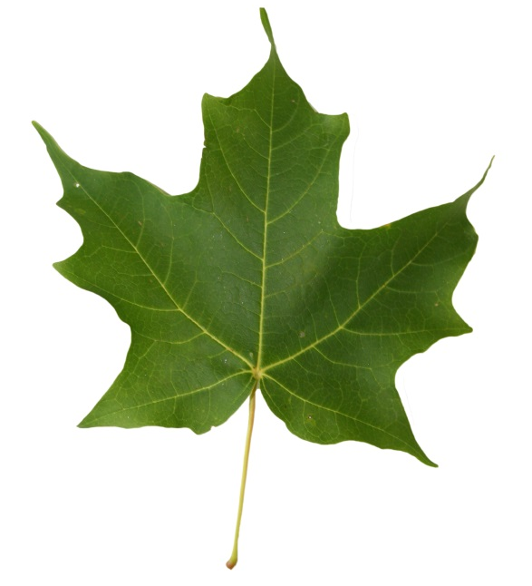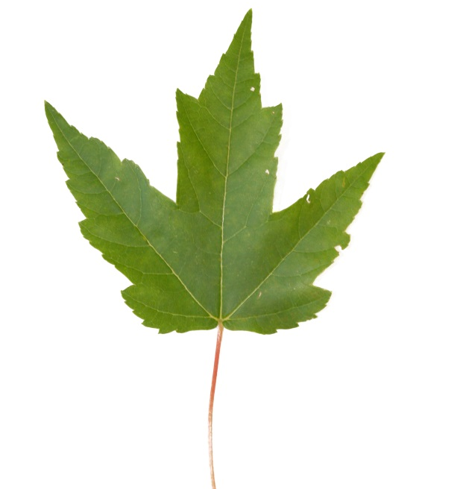
Red Maple (Acer rubra): Look for a jagged leaf edge, three or five lobes, and “V” shaped sinuses.
Sugar Maple (Acer saccharum): Notice the smooth edges, five major points (called lobes), and “U” shaped spaces between the lobes (called sinuses). The sugar maple leaf is represented on the Canadian flag.

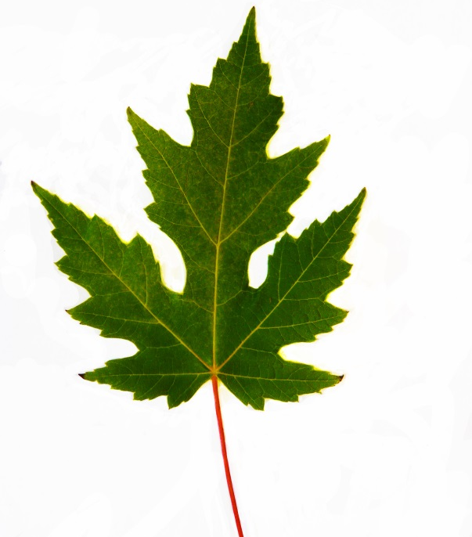
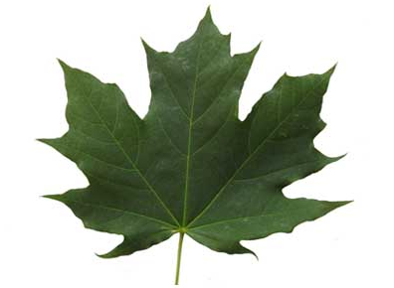
Silver Maple (Acer saccharinum): The silver maple leaf has a jagged leaf edge and deep, curved sinuses that come up to a point at the bottom.

Norway Maple (Acer platanoides): Leaves are similar to sugar maples, but often larger, and produce a white, milky sap at the base of the leaf stem when broken. If you see a maple tree with deep crimson or maroon leaves, it is most likely a Norway maple.

It can be difficult to differentiate between maple species when the leaves are down in winter and early. Look to the buds and bark to determine your maple’s identity. Sugar maple buds are brown, slender, and pointed at the tips. The terminal bud (last one on the branch tip) will usually be in a three-pronged arrangement. Red maple buds are red in color, and blunter and more rounded than sugar maple buds. They tend to grow in clusters. Silver maple buds look similar to red maple, but if you scratch the bark and take a whiff, you may notice an unpleasant odor. In comparison to the other three, Norway maple twigs are thick, with large mahogany-brown buds that come to a point at the tip.
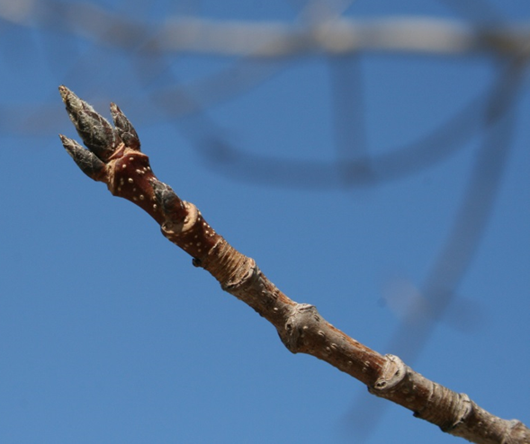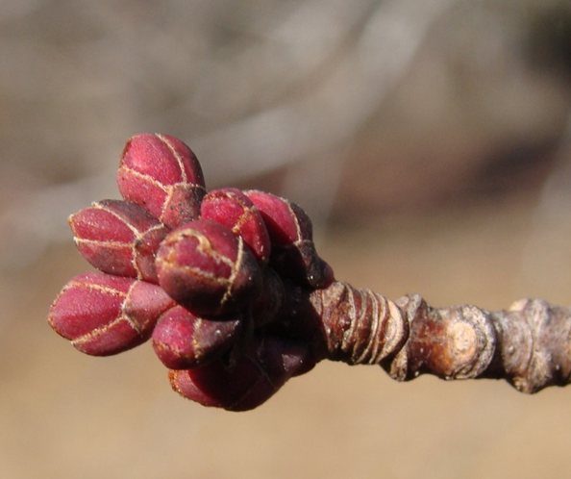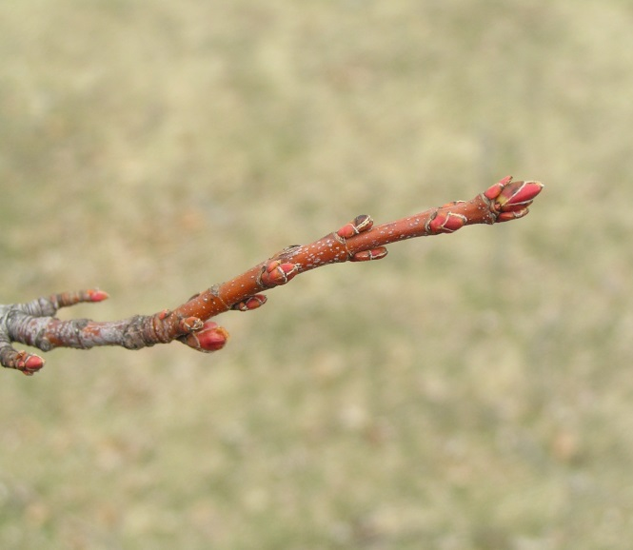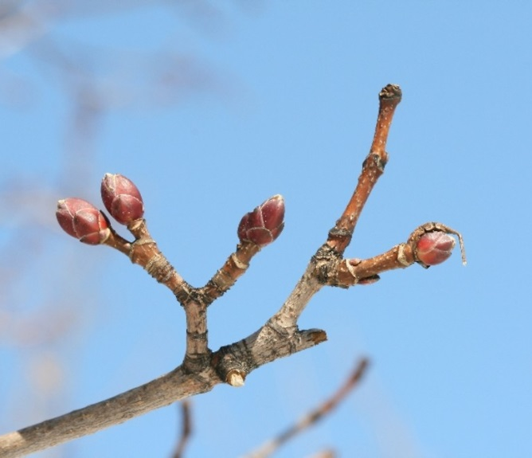
Silver Maple
Norway Maple
Red Maple
Sugar Maple
Tree identification can be tricky— often the leaves are too high to see up close! The texture of bark varies depending on the age of the tree. Red and silver maple buds have many similar characteristics. If you have questions, please do not hesitate to contact Nature Up North. Here are some helpful links:
www.maple.dnr.cornell.edu/pubs/trees.htm
www.leafsnap.com/
www.arborday.org/trees/whattree/

Note: When introducing maple identification to students, it may be helpful to bring in example leaves or buds for reference. It may also be helpful to demonstrate data collection protocol on a single tree before sending students to collect data on their trees.

Tree Tagging (Optional): Although tree tagging is optional due to the possible restraints of your school, we highly recommend doing so if possible. Tree tagging will allow for more reliable data throughout the years as we track individual trees. We can make tree identification tags available for you to use. These will give each tree a unique metal tag with an ID number so that we can keep track of individual trees at your school from year to year. Tag trees 4.5 feet from the uphill side using metal ID tags and an aluminum nail. Tap the nail into the trunk just enough so that it is secure, allowing room for the tree to grow around the nail. Do not tag trees smaller than 9 inches in circumference. Check with the grounds manager at your school before tagging trees.
3. Tree Location
Habitat Type: The best you can, characterize the tree’s habitat and proximity to roads, buildings, and sidewalks by filling out the fields on the data sheet.
Record latitude and longitude: If you are recording data from a mobile device, use the compass function to determine latitude/longitude. If you are entering data on the computer, visit google.com/maps to determine your location. When your cursor is directly over the location of your tree, right click and select “What’s Here?” from the dropdown menu. This will reveal the latitude and longitude in decimal degrees in the search box in the upper left. The coordinates will appear in decimal degrees, such as 44.5941, -75.149756.
4. Tree Size and Health
Measure the circumference: Stand on the uphill side of the tree and measure 4.5 feet from the ground up the trunk. Have one partner hold a finger there to mark the location. Wrap the string or measuring tape around the trunk of the tree so that it is perpendicular to the growth of the trunk. Make sure the measuring tape/string is straight and does not sag or ide up on the backside of the tree. If you used a string, measure the distance of the string using a metal or wooden measuring stick. Record this number so that you do not have to re-measure it during your next observation.

Record Damage/Diseases: These may include broken limbs, dead top, shelf fungi on the trunk, prematurely withered leaves, and more.
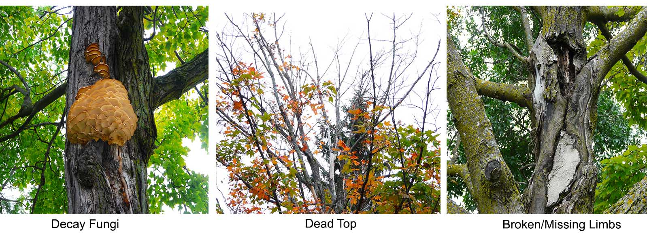

4. Phenology
Collect phenology data: These are the “What is my tree doing now?” questions. In the fall, collect and record data on when leaves begin to change color, when the leaves drop off the tree, and when (and if) fruits form. In the spring, record when maple buds break, when their leaves fully form (unfurl), and when (and if) the tree flowers.
Entering Data:
Data entry is a crucial step because a major strength of citizen science is the ability to crowdsource data from wide geographic area! The more data we have, the better we will be able to accurately recognize trends or changes in maple phenology. Students may enter data in the field directly from a smartphone or record data on paper in their printed laboratory data sheets then enter it into the webform when they go back inside.
Note: Revisit your tree at least once a week throughout the season, spring or fall. The more observations you can record, even if your tree has not changed since the last time you entered data.
Frequently Asked Questions:
- When should I should I start the Monitor My Maple laboratory activity and when should I end it?

In Autumn, collection should start at the beginning of the school year. We ask that you aim to make your first observation in early September, before the leaves on your trees start to change color. Final observations should be completed by the third week of October.

In the Spring, data collection should start in late March or in early April. This should be well before trees leaf out and buds break. Look for buds starting to swell just after maple sugaring season. Do not be afraid to start early, extra data doesn’t hurt! Final observations should be completed after trees have fully leafed out.

Note: Exact dates of data collection may vary depending on the design of your curriculum and the topics that you choose to reinforce with this laboratory activity.

- How often should data be collected?

We ask that you attempt to make observations as often as possible and at minimum of 2-4 times throughout the semester in order to ensure more reliable and wholistic data. The amount of time between each data collection may vary depending on the number of times that you are able to do data collection. If you are able to make 3-4+ data collections, you should aim to do observations every week or two weeks. If it is only possible to do observations twice, you should do an observation every four weeks. It may be useful to ask students to collect data as a homework assignment outside of class time or as extra credit.
Monitor My Maple Tips:
- As soon as you think you’d like to do the Monitor My Maple laboratory activity with your students, contact the Nature Up North team at info@natureupnorth.org or Project Manager Emlyn Crocker directly at ecrocker@stlawu.edu
- Trouble accessing our website? You aren’t alone. Many school security programs limit access to unknown educational tools. Contact your IT staff early to allow access to natureupnorth.org
- Work with Nature Up North staff to select and set up your maple trees before beginning the laboratory with your students. (Can include tagging)
- The first observation will take longer than other observations, especially when including introduction and demonstrations (30-45 minutes). This is because data, such as tree identification and tagging, tree location, and circumference and damages/disease will only be recorded during the initial observation. Observations that follow will only include phenology data making data collection a lot faster! These last observations could be completed after school, as homework, or extra credit.
Note: If you choose, Nature Up North staff can visit your school to introduce citizen science and the Monitor My Maple project for initial observations.
- If possible, have students submit data regularly. This can be done immediately after collecting data, once each week at the same time, or at the end of each month.
- Provide time for students to submit all data to Nature Up North before beginning final reports.
- Please hold one to all paper copies of the data for two months after completing.
We greatly appreciate your participation in this project. If you have any questions, please don’t hesitate to contact us. Check out natureupnorth.org for additional resources and lesson plans! Share photos, class projects, and class news on Nature Up North’s School Blog, http://natureupnorth.org/in-the-schools, to keep the North Country community informed about all of the exciting learning opportunities taking place for our students!

