Name: Period: Date:



Fall Monitor My Maple

*A Place-Based Citizen Science Laboratory Activity*



**Background:**

**Monitor My Maple**is a citizen science project that engages North Country residents in observing the phenology, or seasonal changes, in local maple trees. We benefit from maples in a variety of ways: they provide critical wildlife habitat, high quality timber, gorgeous fall color displays, and, of course, the maple syrup we pour over our pancakes. However, recent research indicates that maple growth is declining in our region, and there is concern among scientists about how a warming and increasingly unpredictable climate will affect both maple health and maple syrup production. Through the Monitor My Maple Project, YOU can help contribute to our knowledge of how climate, habitat, and human activities are affecting these cherished local species.

Why Monitor Maples? By creating a network of people observing and recording the dates of seasonal changes in sugar maples, we can learn a wealth of information about tree health across the North Country. This will help us plan to preserve maple trees and the traditions that surround them.



**Objectives:**

By the end of this activity, you should be able to:

* demonstrate how to find the circumference of a maple tree
* record damages/diseases of maple trees
* observe and record phenology, seasonal changes, in local maple trees
* state the importance and benefits of citizen science



**Materials:**

* A tape measure or cloth measuring tape to measure the circumference of your tree
* A string (if you are using a metal tape measure)
* A paper data sheet or smartphone
* Internet connect (to log observations on natureupnorth.org)
* Tree numbering tags (optional; ask Nature Up North Project Manager for details)

**Procedures: Setting Up a New Tree**



**Tree Identification:**

1. Record your names and the date.
2. Identify and select a maple tree to monitor. Record your data under “New Tree”.

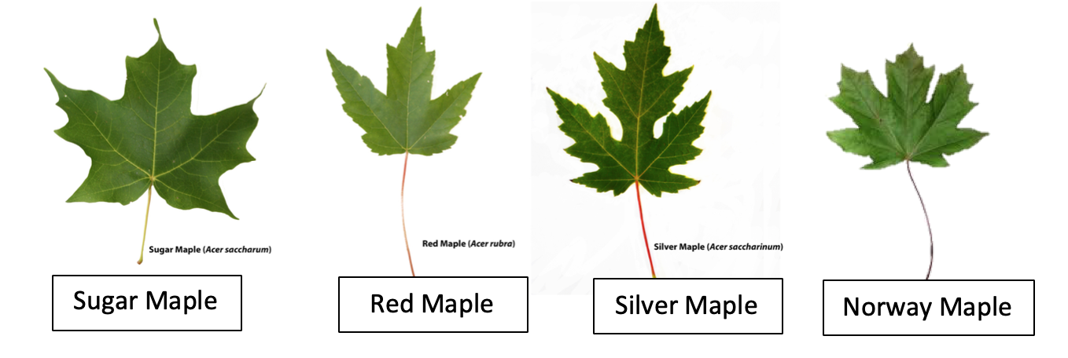

1. Tag trees 4.5 feet from the uphill side using the metal ID tags and an aluminum nail. Tap the nail into the trunk just enough so that it is secure, allowing room for the tree to grow around the nail.

**Tree Location:**

1. Record the latitude and longitude of your maple. Use the compass function on your mobile device or visit google.com/maps.
2. Record the kind of habitat your maple is in. Choose from one of the provided options.

**Tree Size and Health:**

1. Measure the circumference of your tree.
   1. Stand on the uphill side of your tree measure 4.5 feet from the ground up the trunk. One partner should hold their finger there to mark the location.
   2. Wrap the string/measuring tape around the entire width of the trunk. Make sure it is flat and even.
   3. Measure the distance that the string/measuring tape wrapped around the trunk. If you used a string, you may need to use a meter stick to measure the length.
2. Record and damages or diseases that you see on your maple.



**Procedures: Record Phenology Observations**

1. Record your names and the date each time you make an observation.
2. Record observations for color changing in leaves
3. Record observations for leaves dropping
4. Record observations for fruiting(are there seeds?)

**Data Collection: New Tree Datasheet**



You and your partner’s names: Date of observation:

**Tree Identification:**

|  |  |
| --- | --- |
| Maple Species (circle one): | Sugar Maple Red Maple Silver Maple Norway Maple |
| Tree Tag Number: ______ |  |

**Tree Location:**

|  |  |
| --- | --- |
| **Latitude, Longitude:** | **Habitat Type (Choose one from below):** |
|  | school lawn, school garden, school paved area, city or community park (man-made), natural setting (forest, open space), or other |

**Question:** Is your tree within 100 feet of buildings, concrete, or asphalt?

Circle One: YES NO

**Question:** Which of the following descriptions best describes the shading near your maple?

a) Open ( <5 hours per day of direct sun)

b) Partially Shaded (2‐ 5hr per day of direct sun)

c) Shaded (less than 2hr per day of direct sun)

**Tree Size and Health:**

|  |  |
| --- | --- |
| **Circumference (in):** | **Description of Damages/Diseases:** |
| inches  cm  *Be sure to keep the string or measuring tape tight and parallel to the ground |  |

**Additional Comments and Identifying Features:**

**Data Collection: Phenology Observation Datasheet**



You and your partner’s names: Date of observation:

|  |  |
| --- | --- |
| 1. Leaves Changing Color | Check One |

Early— only a few leaves (< 10%)

Middle— many leaves

Late— most or all leaves (>90%)

|  |  |
| --- | --- |
| 2. Leaves Dropping | Check One |

Early— only a few leaves (< 10%)

Middle—many leaves

Late—most or all leaves (>90%)

|  |  |
| --- | --- |
| 3. Fruiting (seeds): | Check One |

None— tree is not fruiting this year

Early— only a few ripe fruit (<10%)

Middle— many fruits are ripe

Late— most or all fruit is dispersed (>90%)

(>90%)

**Additional Comments and Observations:**

**Class Data Summary**



**Table 1. Class data summary of maple tree circumference**

|  |  |  |
| --- | --- | --- |
| **Tree ID Number** | **Circumference (in)** | **Circumference (cm)** |
|  |  |  |
|  |  |  |
|  |  |  |
|  |  |  |
|  |  |  |
|  |  |  |
|  |  |  |
|  |  |  |
|  |  |  |
|  |  |  |
|  |  |  |
|  |  |  |
|  |  |  |
|  |  |  |
|  |  |  |
|  |  |  |
|  |  |  |
|  |  |  |
|  |  |  |
|  |  |  |
|  |  |  |
|  |  |  |
|  |  |  |
|  |  |  |
|  |  |  |
|  |  |  |
|  |  |  |
|  |  |  |
| **Total Circumference:** |  |  |
| **Average Circumference:** |  |  |
|  |  |  |

**Analysis Questions: *Example***



**Problem/Question:** Does the amount of sun exposure effect the annual growth of maple trees?

**Observations:** Citizen scientists from schools in the North Country will collect data about maple tree health, size, and habitat.

**Experimental Design:**

**Title:** The Effect of Shading on Maple Tree Circumference

**Hypothesis:** If maple trees are located in areas with less shade, then they will have

larger circumferences because sunlight is used for photosynthesis which

provides energy for tree growth.

**Independent Variable:** Amount of Shade

**Dependent Variable:** Maple Tree Circumference (in)

**Results: Raw Data**

|  |  |  |
| --- | --- | --- |
| **Tree ID Number** | **Amount of Shade** | **Maple Tree Circumference (in)** |
| 1 | Partially Shaded | 48 |
| 2 | Shaded | 46 |
| 3 | Shaded | 46 |
| 4 | Open | 132 |
| 5 | Partially Shaded | 43 |
| 6 | Open | 37 |
| 7 | Open | 77 |
| 8 | Open | 35 |
| 9 | Partially Shaded | 86 |
| 10 | Partially Shaded | 27 |
| 11 | Shaded | 9 |
| 12 | Shaded | 22 |
| 13 | Shaded | 65 |
| 14 | Partially Shaded | 43 |
| 15 | Open | 89 |
| 16 | Open | 62 |
| 17 | Shaded | 39 |
| 18 | Shaded | 10 |
| 19 | Partially Shaded | 42 |
| 20 | Partially Shaded | 43 |
| 21 | Open | 56 |

**Results: Summarized Data**

|  |  |  |  |
| --- | --- | --- | --- |
|  | **Shaded** | **Partially Shaded** | **Open** |
| **Average Circumference** | 33.9 inches | 47.4 inches | 69.7 inches |

**Note: To find the average tree circumference for each amount of shading, add up the circumferences for each amount of shading and divide the total by the number of trees.**

Example: Find the average maple tree circumference for trees in shaded areas.

46 + 46 + 9 + 22 + 65 + 39 + 10 = 237 inches

**= 33.9 inches**

$$\frac{237 inches}{7 maple trees}$$

**Graph:**



**Conclusion:** The results support my hypothesis because maple trees in less shaded areas had a greater average circumference (in) then maple trees in shaded areas.

**Analysis Questions: Your Turn!**



**Problem/Question:**

**Observation:** Citizen scientists from schools in the North Country collect data about maple tree health, size, and habitat. …

**Experimental Design:**

**Title:**

**Hypothesis:**

**Independent Variable:**

**Dependent Variable:**

**Results:**

|  |  |  |
| --- | --- | --- |
| **Tree ID Number** |  |  |
|  |  |  |
|  |  |  |
|  |  |  |
|  |  |  |
|  |  |  |
|  |  |  |
|  |  |  |
|  |  |  |
|  |  |  |
|  |  |  |
|  |  |  |
|  |  |  |
|  |  |  |
|  |  |  |
|  |  |  |
|  |  |  |
|  |  |  |

**Graph:**



**Conclusion:**

**Communicate Your Results:** Share your results and data with Nature Up North at natureupnorth.org!