Phenology Activity
Select the Season Relay Race

Description:
This is a simple relay race game designed to help students identify classic examples of New York phenological events. The full set, available soon at natureupnorth.org or by mail from Nature Up North consists of 30 laminated cards, 15 representing spring phenology events and 15 representing fall phenology events. Students are challenged to work in teams and identify which season pictures belong in.

Directions for teachers:
- Before starting, make sure you have the teacher cheat sheet of answers for which cards represent fall phenology and which represent spring. Write “Fall” on one sheet of construction paper and “Spring” on the other. Laminate if you will use this lesson again. These are the destinations for students to use when sorting the photos during the race. Tape them to Tupperware bins or have students pile cards directly on paper.
- Mix fall and spring cards evenly.
- Starting the game: Split students in two even groups for the relay race. Review general rules for relay— you can decide end zone, etc. This works well in a gym or outside.
- Place the cards in a pile on the end zone line, opposite the students. You can place the cards on the ground or in a bin/basket, either works. They should be all together and mixed.
- Place the “Fall” and “Spring” signs in near the two teams.
- Tell students that there are two types of cards, one type has pictures of autumn phenology, the other type has pictures of spring phenology. Their job is to run down, grab a card, run back with the card and have the team help them decide which pile to place it on. Then, they tag the next person in line & go to the end of the line. First team to have all team members participate wins.
- Encourage and help the students as they participate. After the race ends, congratulate the winners and move on quickly to looking at the results. If desired, you can have students keep team answers separate to compare how well then did. Correct any phenology pictures placed in the wrong pile, and facilitate a group discussion surrounding results. Could any photos be placed in either pile correctly? Why?

Three example cards. *more cards need to be developed for this activity. Make your own, or contact Emlyn at ecrocker@stlawu.edu if you plan to use this activity.

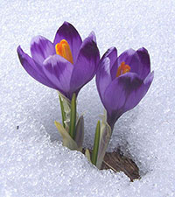
Crocus Flower
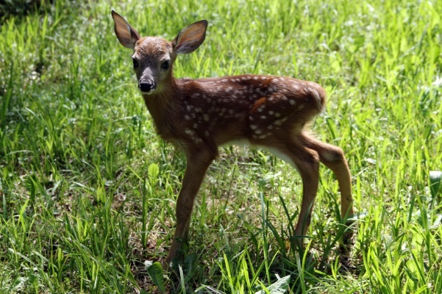
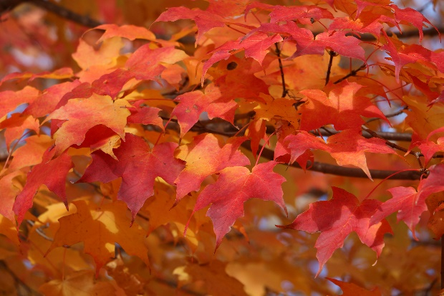
Fawn
Maple Leaves

